Programming Assignment Unit 7
Part 1
Write a function called has_duplicates that takes a string parameter and returns True if the string has any repeated characters. Otherwise, it should return False.
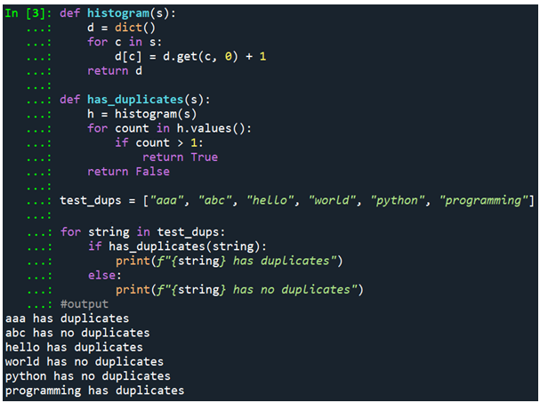
The code above shows how a dictionary containing the counts of each character in the input string has been created using the histogram function. To show that there are duplicates, the has_duplicates function checks the histogram for any count greater than 1. As a result, the function returns True; otherwise, it returns False incase duplicates are present. To determine if the string has any repeated characters, the loop iterates through each string in the test_dups list and calls the has_duplicates function. Thereafter, it prints the result accordingly by indicating whether the string has duplicates or not.
Part 2
Write a function called missing_letters that takes a string parameter and returns a new string with all the letters of the alphabet that are not in the argument string. The letters in the returned string should be in alphabetical order.
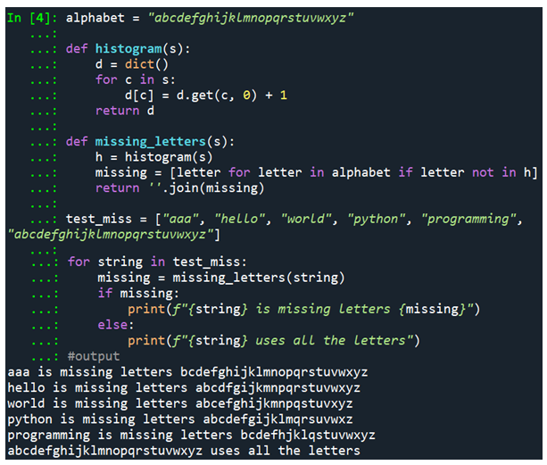
The missing_letters function takes a string as input and uses the histogram function to build a histogram of the characters. The alphabetic characters not found in the input string are then located using a list comprehension and combined into a new string. The function returns an empty string if each letter of the alphabet is present. The loop invokes the missing_letters function to identify the missing letters as it iterates over each string in the test_miss list. It then outputs the outcome appropriately, noting any missing letters or whether the string contains every letter of the alphabet.

